Membership Form 2022
January 01, 2022 – December 31, 2022
(Please Print Clearly)
First Name____________________________ Last Name_____________________________
Family Members______________________________________________________________
Address_____________________________________________________________________
City______________________________________ State_______________ Zip____________
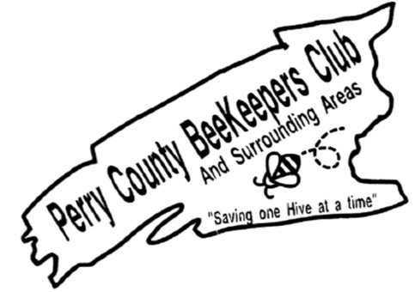
Email_________________________________________ Phone_________________________
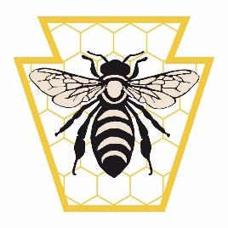
Perry County Beekeeper Membership
(Circle your Membership Choice)
Individual $20 Family $25 Junior $1
PA Beekeepers Association
Individual $20 Family $25 Junior $1

Total Paid $____________
Approved by Treasurer _____________________
If mailing check, please send check and completed membership form to:
Perry County Beekeepers Club
300 Flint Drive Landisburg, PA 17040
-------------------------------------------------------- ***CASH RECEIPT*** ----------------------------------------------------
Date_________________ Amount Received $______________

Name_______________________________________________
****************************Please be sure to fill out the back!!!!!***************************

Volunteer Section
_____ I am interested in being part of the Fundraiser Committee
(Check all that apply)
___ I am interested in reaching out to vendors for donations
___I am interested in helping getting donations for Raffles

_____I am interested in being part of the Educational Committee

_____ I am interested in volunteering time at event
(Check all that apply)
____Perry County Fair ___Heritage Day____Apple Fest____ ALL

Best days to volunteer
___ Sunday____Monday___Tuesday____Wednesday____Thursday___Friday____Saturday

_____ I am interested in instructing at the Beekeeping School

_____I am interested in helping in the kitchen at the Beekeeping School

Confirm Name_______________________________
Email ______________________________________
Phone number_______________________________

