Membership Form 2025
January 01, 2026– December 31, 2026
(Please Print Clearly)
First Name____________________________ Last Name_____________________________
Family Members______________________________________________________________
Address_____________________________________________________________________
City______________________________________ State_______________ Zip____________
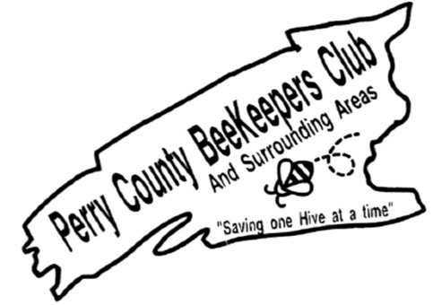
Email_________________________________________ Phone_________________________
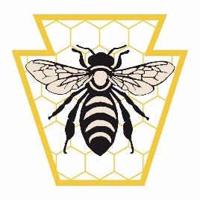
Perry County Beekeeper Membership
(Circle your Membership Choice)
Individual $20 Family $25 Junior $1
PA Beekeepers Association
Individual $20 Family $25 Junior $1

Total Paid $____________
Approved by Treasurer _____________________
If mailing check, please send check and completed membership form to:
Perry County Beekeepers Club
300 Flint Drive Landisburg, PA 17040

Please allow up to 30 days for processing. You will receive a membership card in the mail.
Please check if you want to have your information put on public club membership list
Please check if you don’t want your picture used on social media

