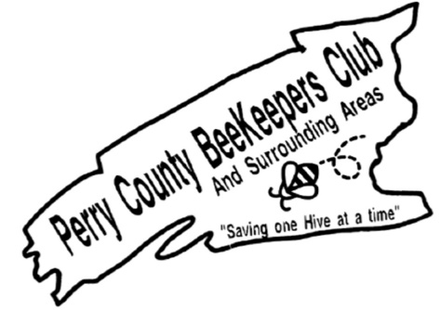
Beekeepers Class 101
February 4, 2022
8:00 am – 3:30 pm
Cost $30 Includes Book & Lunch
PLEASE PRINT CLEARLY
First Name____________________________
Last Name_____________________________
Address: ______________________________
__________________________Zip_________
Phone: (_______) ________-_____________
Email: _______________________________
Additional Registrations - Names:
__________________________________
__________________________________
Total enclosed at $30 per person: $__________
PLEASE MAIL WITH CHECK PAYABLE TO:
Perry County Beekeepers Club
300 Flint Drive
Landisburg PA 17040
Please email questions to Secretary-Treasurer:
Perrycountybeekeepersclub@gmail.com

