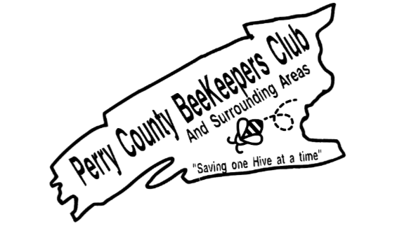

Perry County Beekeepers Club
Membership From
Perry County Beekeepers | PA State Membership
Individual membership $20.00 | Individual $20.00
Family $25.00 | Family $25.00
Junior $1.00 (Under 17) | Junior $1.00 (under 17)
 | Life Time $200.00
PA Apiary Registration 2 years for $10.00 (This is for Registration only with the PA Apiary)
All local membership and state membership are for 1 year. If you select Local, Stated and Inspection you will receive $5 off Perry County’s Beekeepers membership. For every PA State membership, Perry County Beekeepers will receive $2.00 from the state if you register through Perry County Beekeepers Club.
First Name ____________________Last Name ________________________
Addresss _______________________________________________________
City __________________________ State___________________Zip _______
Date ___________________ Signature of Member _____________________
Total Cost _______________
PAID ____________________ Signature of Treasurer_____________________
Send Check or money order to:
Perry County Beekeepers Club
Tereasa Houtz Treasurer
300 Flint Drive
Landisburg, PA 17040

